

**AGGRESSION DETECTION**

**BY**

**chirag shastry**

**Surabhi nagendra**

**Aishwarya kiran**

**adithya ramesh**

**PROBLEM STATEMENT:**

To design an android application to detect the aggression level, with importance to patients suffering from Alzheimer’s

and dementia after acquiring the specific characteristics of the patient. Different parameters such as Heart rate, Blood Pressure, Motion Detection and most importantly Speech Recognition technology.

**Introduction:**Our approach to the problem was based on parameters such as blood pressures, heartbeat, motion detection and Speech recognition.

Its implementation is done through a single android wearable, which will detect the different the parameters such as heart beat, blood pressure with a common sensor, whereas the other parameters like motion detection are done through accelerometer and speech recognition is done through a microphone which can either made be interfaced with wearable sensor and or be embedded in a patient’s cloth and then can be connected through a blue-tooth.

Our Solution:

There are 3 phases in the implementation:

1. First Phase: This phase includes the monitoring and detecting the parameters mentioned above from the patient and then sending the values to the database.

The Alzheimer’s patient’s activities are notified and compared with a base value in the processing part.

1. Second Phase: This is the processing part which has both front end and back end.

In the backend, the received input is differentiated into different parts and then processed. They are actually compared with pre-determined values of the parameters of the patients in which it will be triggered to a text.

The next step is that the text will then be divided into different variables, with each variable being measured separately.

1. Final Phase: In this phase, the output will be of two stages- one output will be continuously displayed on the UI, to make it available for those who are using the website and the other output will be given to the care-taker based upon the conditions.

Equipment Required:  
Wearable Android Watches, Accelerometers, Microphone, WLAN – Connectivity.

Our Approach:

Our work is based upon the use of PHP, java, XML, we are also planning to make use of Google APIs provide for processing part and the UI output will be on Android platform.

The problem that we would be facing is knowing the pre-determined values of the parameters, as a small change in it will produce unnecessary signals to the care-taker.

Depending upon the level of these parameters above their base line, the android wear with the care taker will give corresponding signals so that the patient does not turn hostile.

**DATA FLOW**

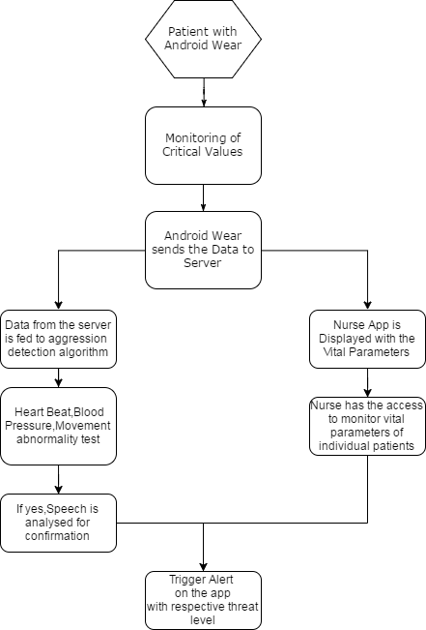

According to the above displayed flow graph, the patient is monitored for the different values through the android wear and then the same is sent to the server, where the values are stored dynamically.

These values are then converted to independent variables in the detection algorithm and the same is compared with their baseline values.

We are taking the primary detection parameters as heartbeat, blood pressure and movement detection, whereas, the secondary parameter is Speech analysis, but with higher preference given.

The algorithm is such that, the first stage of triggering the text is based upon the values of heart rate, blood pressure, motion detection ,if these values show abnormality, then the speech detection is checked for variations, if both the conditions are

Satisfied, then the next level is about the level of aggression detection, as in whether the patient is under normal circumstances, person is on the verge of aggression, the patient has turned hostile.

The webpage or the UI interface in the Desktop will display, continuously, the recorded values, ready to be accessed at any time.

The android wear with the Nurse will also display these details, but in a more constrained way, such that it will be more concentrated in displaying a three-signal output, depending upon the aggression level, with taking into consideration a considerable amount of time for the care-taker to respond to the patients.

**CONTROL DIAGRAM**

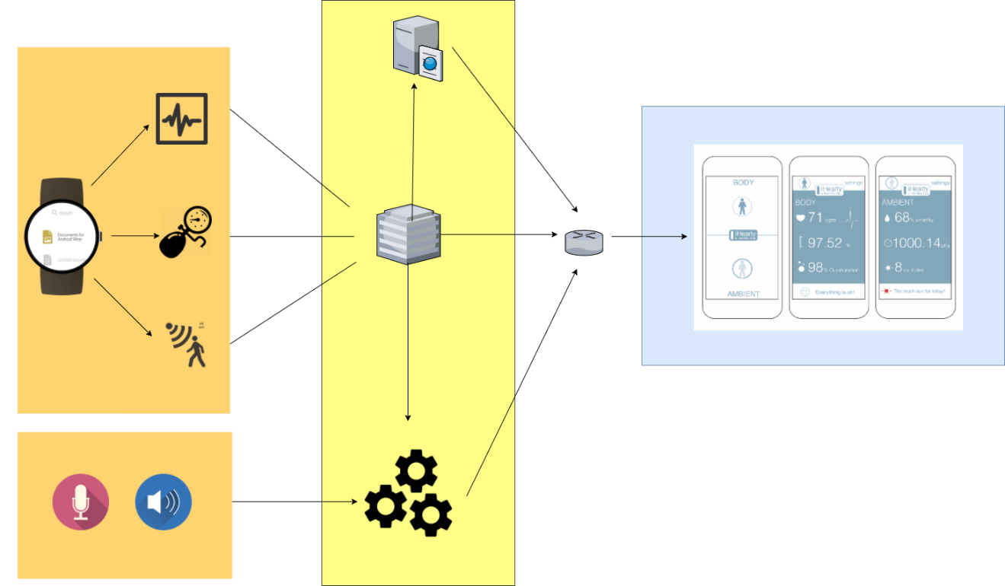

The above diagram gives an essence of the entire control and processing.

* Wearable watch: Records the physical parameters such as heart beat, blood pressure, and hand and/or leg motions.
* MIC – Detects the difference in decibel levels.
* Output from android wear Processing system.
* The processing system will have a computational unit, backend and frontend application.
* The frontend will display the output to the caretaker and also in the website, whereas the triggering part is done in computational part.
* Initially, the wearable watch detects the changes in physical parameters such as heart rate, blood pressure and sudden body movements of the patient.
* At the same time, the MIC will sense the changes in the decibel levels of the patient which may sometimes be the initial symptoms of aggressive behavior.
* In the above diagrammatic representation, we can see that all these parameters that have been detected is sent to the processing unit to generate signals/data that will trigger the display.
* We have an existing database which contains the medical records of the patient contributing to the patient’s information. Using this, we can compare the obtained data from the sensors to the data which already exists. This will indicate whether or not the patient suffering from Alzheimer’s or Dementia is on the verge of showing aggressive behavior. The processing unit consists of a computational device which has backend and frontend applications.
* It enables the data obtained from the server to be supplied to the website or an app that the caretaker is handling.
* The UI interface in the desktop will receive and display the obtained results, enabling the user to interact with the webpage. The android app that the caretaker will be using will also display the results in the form of three colors, green, yellow and red depending on the level of aggression. Each colors is assigned a specific range which will indicate different levels of aggression.
* The caretaker can then assist the patient.

Processing

Among the various parameters that we have considered, we have considered the following as the prime parameters for aggression:

1. The repetition of certain words or phrases by an Alzheimer’s and dementia patients.
2. The variations in decibel levels as the person becomes aggressive.

The secondary parameters for aggression that we will be considering are:

* The increase in the blood pressure of the patients.
* The increase in the heart rate.
* Sudden Movements in the joints of the patient.

Reasons to choose the above as secondary parameters are:

There are other medical reasons why the blood pressure of a patient can vary such as high blood pressure, diabetes.

As Alzheimer’s and dementia is found commonly in elderly people, their heart rate is generally low and can vary.

Sudden Movements are found only when a person is too aggressive and cannot be considered as a prime parameter to detect aggression.

WORKING

Firstly, the collection of all the patients’ medical history needs to be loaded onto a database. These details will serve as the basic comparison parameter (baseline) to detect the aggression in an individual.

The output from all the sensors are read and processed as follows:

Any changes in the above parameters will be notified to the caretaker on an hourly basis.

To detect the various level of changes in the aggression of the patients we calculate the level of aggression by multiplying the changes in each of the parameters with a predefined priority values.

The value that is obtained is then checked for the range it lies in and from this the level of detection will be concluded.

* If the value of the levels of aggression is below the normal levels, the caretaker will not be notified.
* If the value of the levels of aggression is in tolerable level, then the caretaker is warned.
* If the value of the levels of aggression is above the tolerable level, then the caretaker is alerted with an immediate assistance required message

The priority order of the parameters is as follows

Highest priority to lowest priority

Class One

* + - Speech Recognition
    - Decibels Levels

Class Two

* + - BP Levels
    - Heart rate
    - Sudden movements